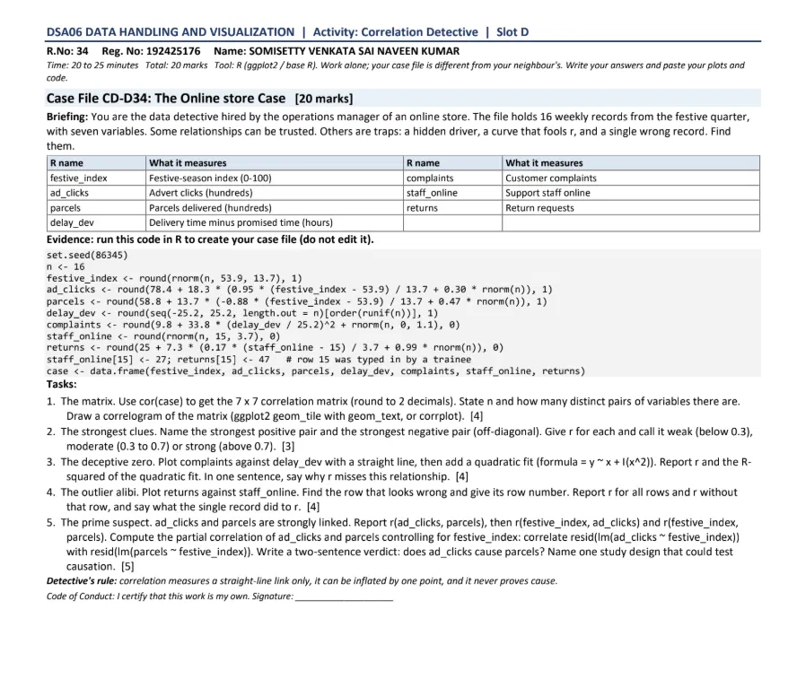

R Code (Case File)
set.seed(86345)
n <- 16
festive_index <- round(rnorm(n, 53.9, 13.7), 1)
ad_clicks <- round(78.4 + 18.3 * (0.95 * (festive_index - 53.9) / 13.7 + 0.30 * rnorm(n)), 1)
parcels <- round(58.8 + 13.7 * (-0.88 * (festive_index - 53.9) / 13.7 + 0.47 * rnorm(n)), 1)
delay_dev <- round(seq(-25.2, 25.2, length.out = n)[order(runif(n))], 1)
complaints <- round(9.8 + 33.8 * (delay_dev / 25.2)^2 + rnorm(n, 0, 1.1), 0)
staff_online <- round(rnorm(n, 15, 3.7), 0)
returns <- round(25 + 7.3 * (0.17 * (staff_online - 15) / 3.7 + 0.99 * rnorm(n)), 0)
staff_online[15] <- 27; returns[15] <- 47 # row 15 was typed in by a trainee
case <- data.frame(festive_index, ad_clicks, parcels, delay_dev, complaints, staff_online, returns)

Task 1. The matrix [4]

R Code
cor_mat <- round(cor(case), 2)
print(cor_mat)
nrow(case) # n
choose(7, 2) # distinct pairs

cm <- as.data.frame(as.table(cor_mat))
ggplot(cm, aes(Var1, Var2, fill = Freq)) +
geom_tile(colour = "white") +
geom_text(aes(label = sprintf("%.2f", Freq)), size = 3) +
scale_fill_gradient2(low = "blue", mid = "white", high = "red", limits = c(-1, 1)) +
labs(x = NULL, y = NULL, fill = "r") + theme_minimal() +
theme(axis.text.x = element_text(angle = 45, hjust = 1))
Key: FI = festive_index, AD = ad_clicks, PA = parcels, DD = delay_dev, CO = complaints, SO = staff_online, RE = returns.
 | FI | AD | PA | DD | CO | SO | RE
FI | 1.00 | 0.97 | -0.91 | 0.12 | 0.28 | 0.01 | 0.08
AD | 0.97 | 1.00 | -0.90 | 0.10 | 0.19 | 0.05 | 0.06
PA | -0.91 | -0.90 | 1.00 | -0.05 | -0.15 | 0.02 | -0.14
DD | 0.12 | 0.10 | -0.05 | 1.00 | -0.03 | 0.22 | 0.21
CO | 0.28 | 0.19 | -0.15 | -0.03 | 1.00 | 0.32 | 0.63
SO | 0.01 | 0.05 | 0.02 | 0.22 | 0.32 | 1.00 | 0.67
RE | 0.08 | 0.06 | -0.14 | 0.21 | 0.63 | 0.67 | 1.00

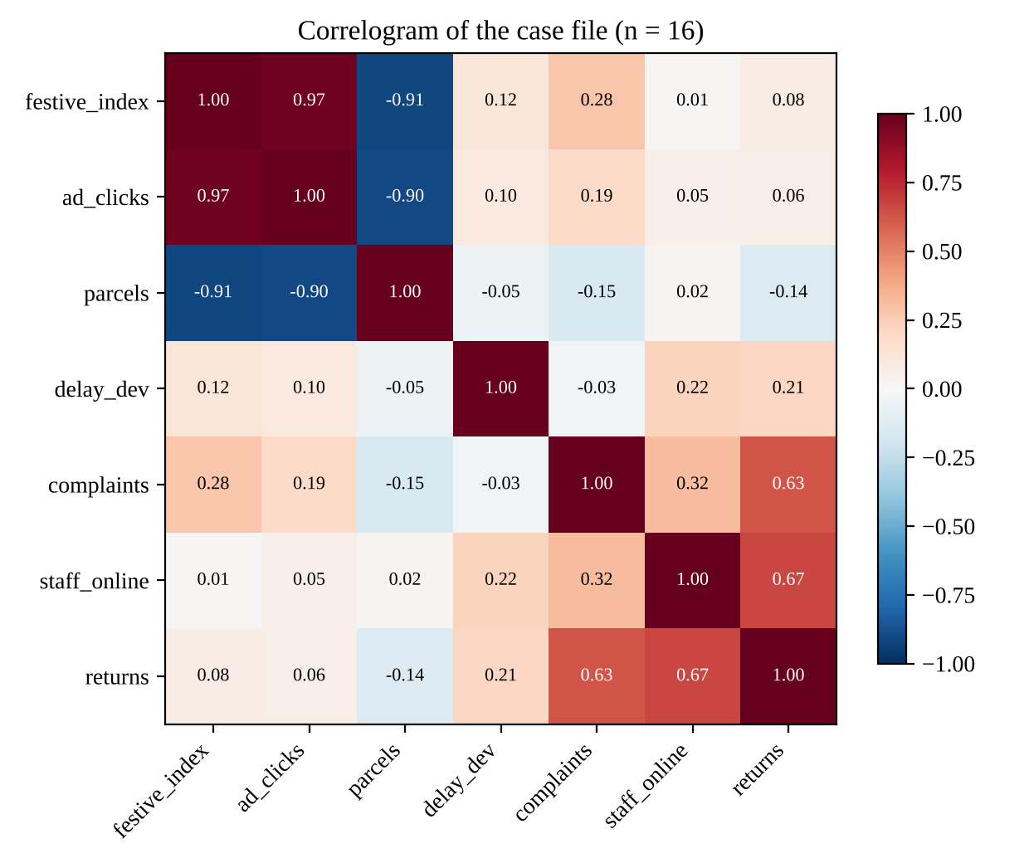
Figure 1. Correlogram of the 7 x 7 correlation matrix
The sample size is n = 16 weekly records. With 7 variables there are 7 x 6 / 2 = 21 distinct pairs of variables (the matrix has 49 cells, of which 7 are the diagonal and the other 42 are mirror images).

Task 2. The strongest clues [3]

R Code
pairs <- as.data.frame(as.table(cor(case)))
pairs <- pairs[as.integer(pairs$Var1) < as.integer(pairs$Var2), ]
pairs[which.max(pairs$Freq), ] # strongest positive
pairs[which.min(pairs$Freq), ] # strongest negative
The strongest positive pair is festive_index and ad_clicks, with r = 0.97, which is strong (above 0.7). The strongest negative pair is festive_index and parcels, with r = -0.91, which is also strong. Close behind it is ad_clicks and parcels with r = -0.90 (strong). The next positive pairs are staff_online with returns (r = 0.67) and complaints with returns (r = 0.63), both moderate (0.3 to 0.7); every other pair is weak (below 0.3 in size).

Task 3. The deceptive zero [4]

R Code
cor(case$delay_dev, case$complaints)

ggplot(case, aes(delay_dev, complaints)) +
geom_point() +
geom_smooth(method = "lm", se = FALSE, colour = "red") +
geom_smooth(method = "lm", formula = y ~ x + I(x^2), se = FALSE, colour = "blue")

fit <- lm(complaints ~ delay_dev + I(delay_dev^2), data = case)
summary(fit)$r.squared
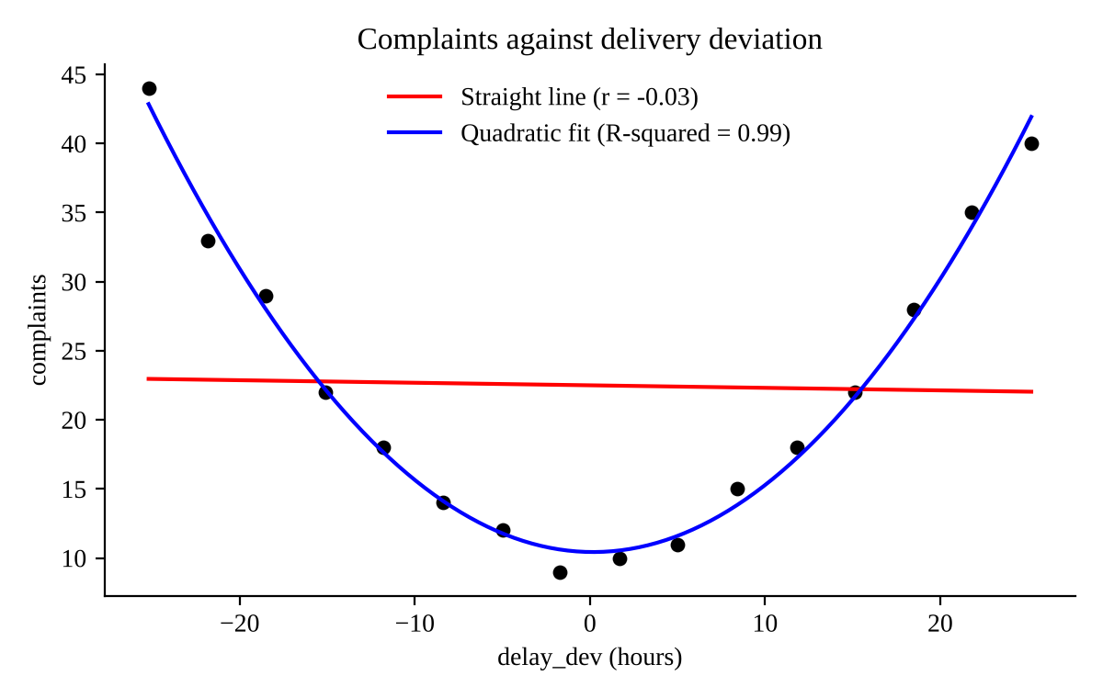
Figure 2. Complaints against delay_dev with a straight line (red) and a quadratic fit (blue)
The straight-line correlation is r = -0.03, essentially zero. The quadratic fit (complaints = 10.43 - 0.018 x delay_dev + 0.0503 x delay_dev squared) has an R-squared of 0.99. The relationship is a strong U-shape: complaints are lowest when delivery is close to the promised time and rise steeply for both early and late deliveries. The correlation coefficient r misses it because r measures only straight-line association, and the falling left arm of the curve cancels the rising right arm, leaving a flat overall slope.

Task 4. The outlier alibi [4]

R Code
ggplot(case, aes(staff_online, returns)) +
geom_point() +
geom_point(data = case[15, ], colour = "red", size = 3) +
geom_smooth(method = "lm", se = FALSE)

case[which.max(case$returns), ] # the suspicious row
cor(case$staff_online, case$returns) # all rows
cor(case[-15, ]$staff_online, case[-15, ]$returns) # without row 15
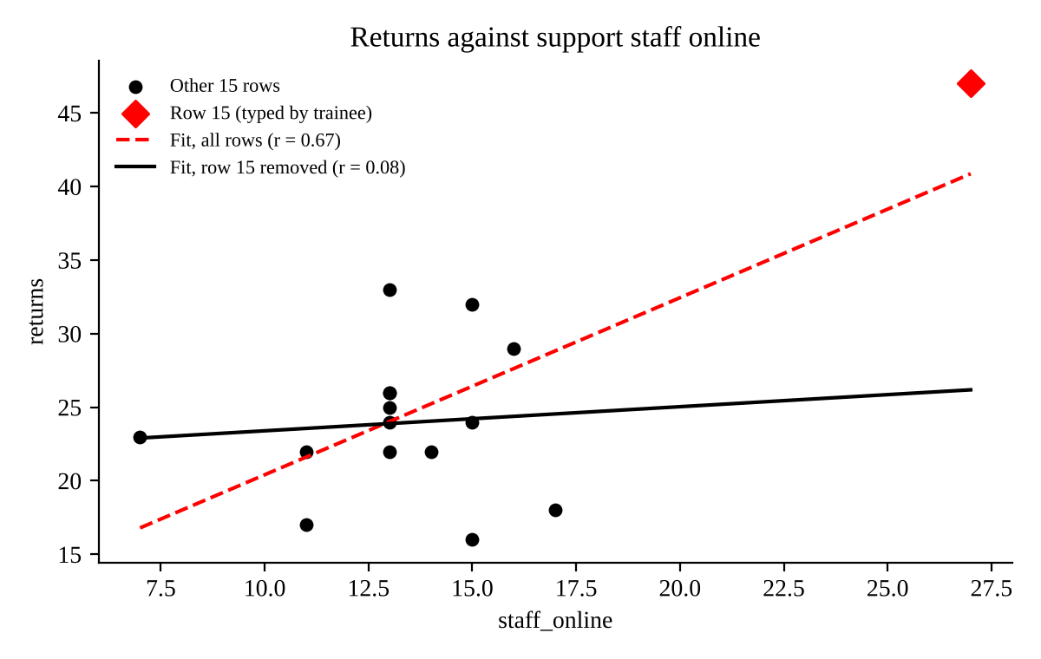
Figure 3. Returns against staff_online; row 15 is the red diamond
The row that looks wrong is row 15 (staff_online = 27 and returns = 47, with the trainee-typed values). Both values are far above every other record: no other week has more than 17 staff online or more than 33 returns. With all 16 rows r = 0.67 (moderate), but without row 15 it falls to r = 0.08 (weak, essentially none). The single record therefore dragged the line upward and created an apparent link that does not exist in the other 15 weeks.

Task 5. The prime suspect [5]

R Code
cor(case$ad_clicks, case$parcels)
cor(case$festive_index, case$ad_clicks)
cor(case$festive_index, case$parcels)

ra <- resid(lm(ad_clicks ~ festive_index, data = case))
rp <- resid(lm(parcels ~ festive_index, data = case))
cor(ra, rp) # partial correlation
Quantity | Value
r(ad_clicks, parcels) | -0.90
r(festive_index, ad_clicks) | 0.97
r(festive_index, parcels) | -0.91
Partial r (ad_clicks, parcels | festive_index) | -0.13

Verdict. No: ad_clicks does not cause the change in parcels. The strong link (r = -0.90) almost disappears once festive_index is held constant (partial r = -0.13), because festive_index is a hidden driver that moves both variables (r = 0.97 with ad_clicks and r = -0.91 with parcels). A study design that could test causation is a randomised experiment: randomly assign regions or weeks to receive higher or lower advert spending at the same festive intensity (an A/B or geo-split test) and compare parcels delivered between the groups.
Detective's rule: correlation measures a straight-line link only (Task 3), it can be inflated by one point (Task 4), and it never proves cause (Task 5).

